**AIPLIRS Core v2.1 (Patch released: July 20, 2022)**

[**http://172.16.8.7:628/pages/posmd/antemortem_slh.php**](http://172.16.8.7:628/pages/posmd/antemortem_slh.php)

**Other column not filtering from code -> disease**

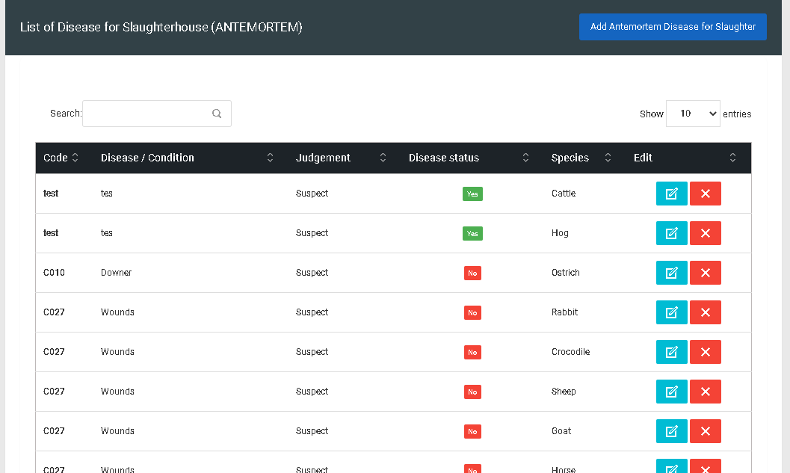

**Species must have select / deselect all function**

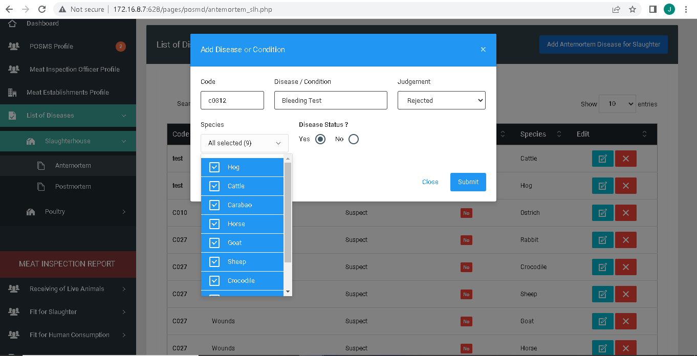

**Duplicated input multiple species**

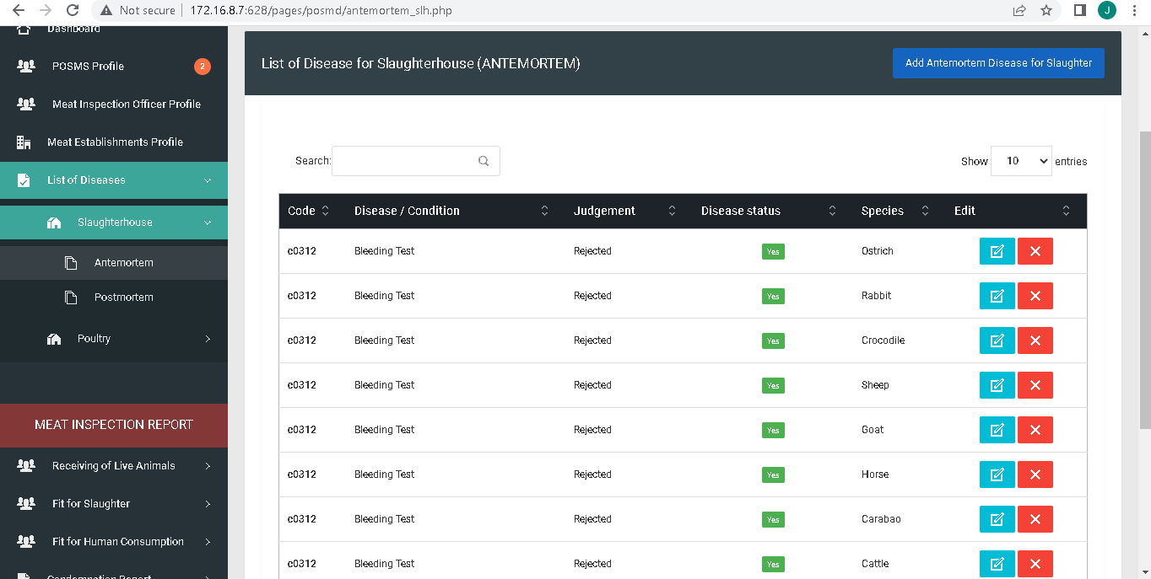

**Title**

**http://172.16.8.7:628/pages/posmd/antemortem_slh.php**

**Add Diseases or Conditions**

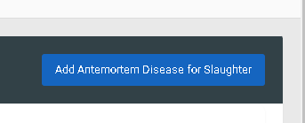

**Diseases and Conditions**



**Remove question mark disease status and change the option yes or no to Notifiable / Not Notifiable**.

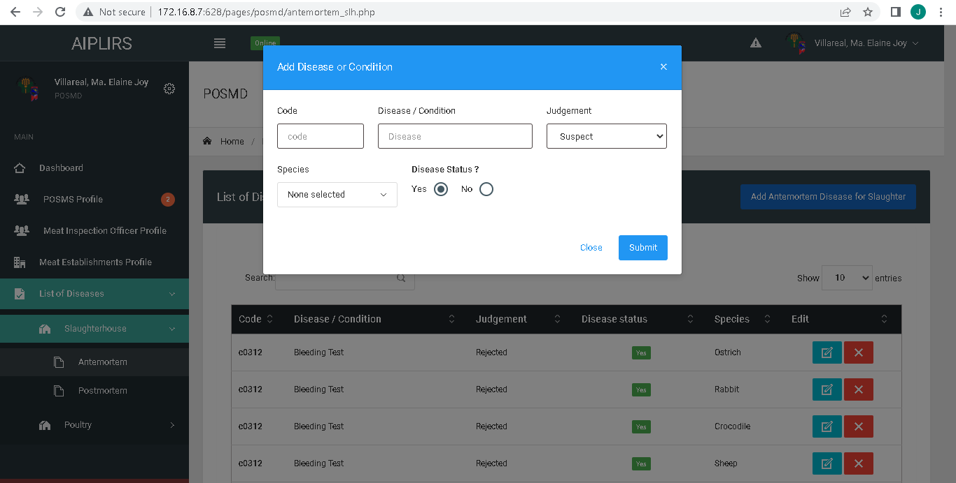

**Remove question mark disease status and change the option yes or no to Notifiable / Not Notifiable.**

**Position of species in bottom**

**Update multiples species 1 and another species the same with add AM/ PM thick box**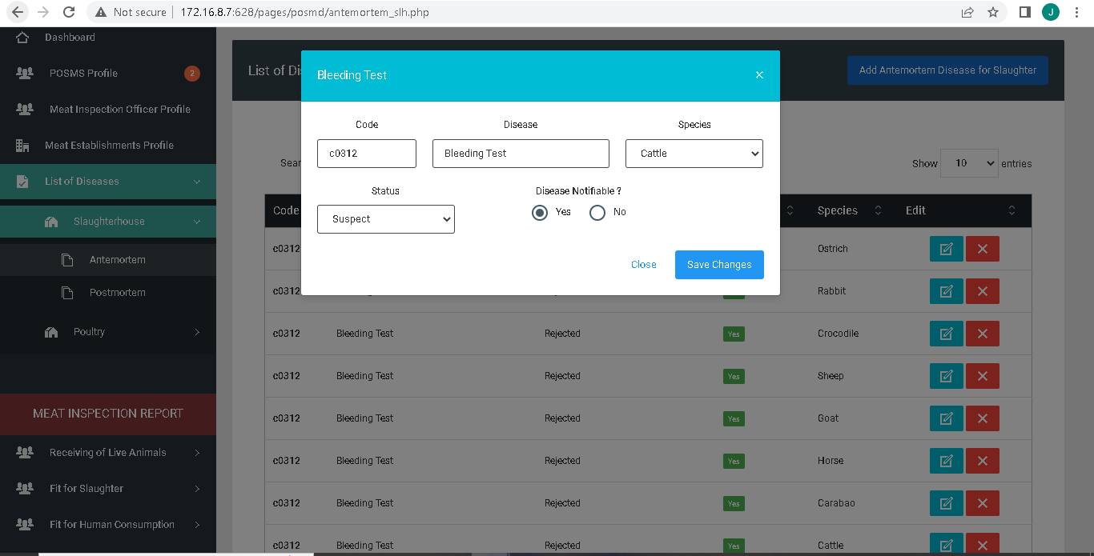

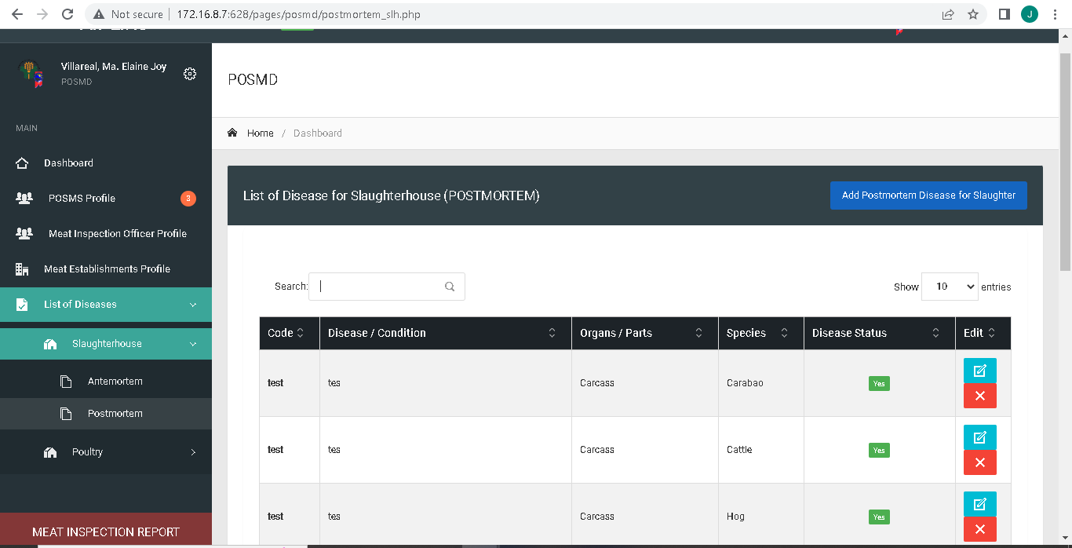

**Employee code to Employee Number and change contact to contact number , contact numbers must be a number format**

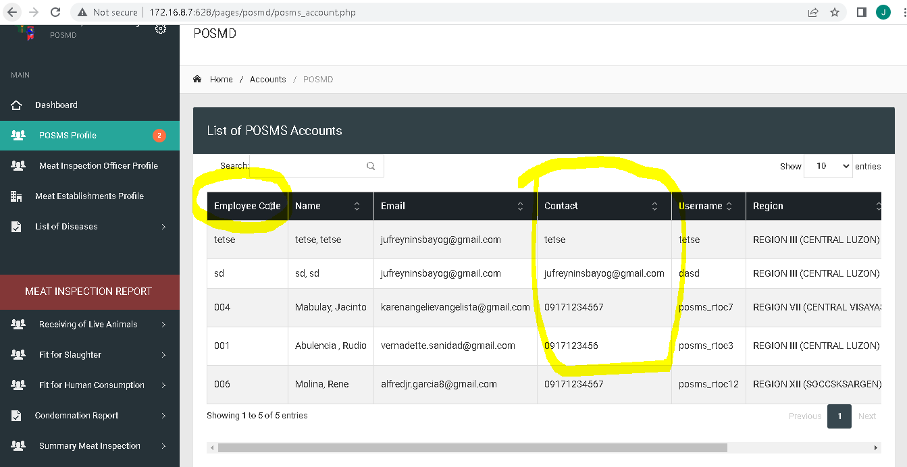

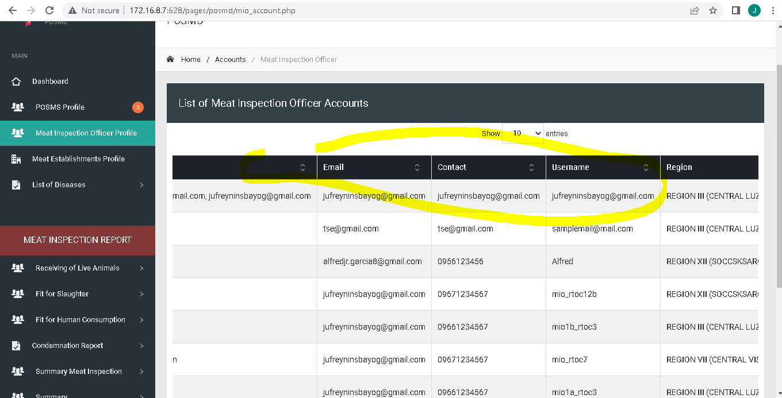

**Change list of posms accounts to posms accounts**

**Sidebar: Changer “Profile” to “Accounts”**

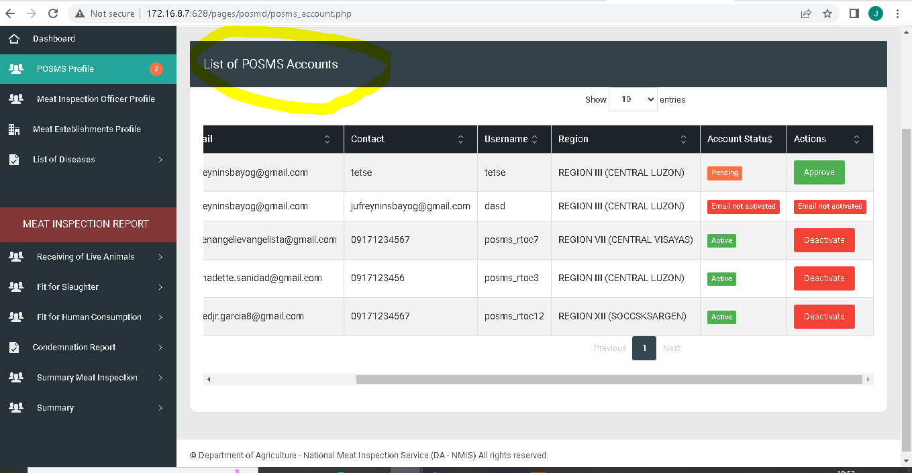

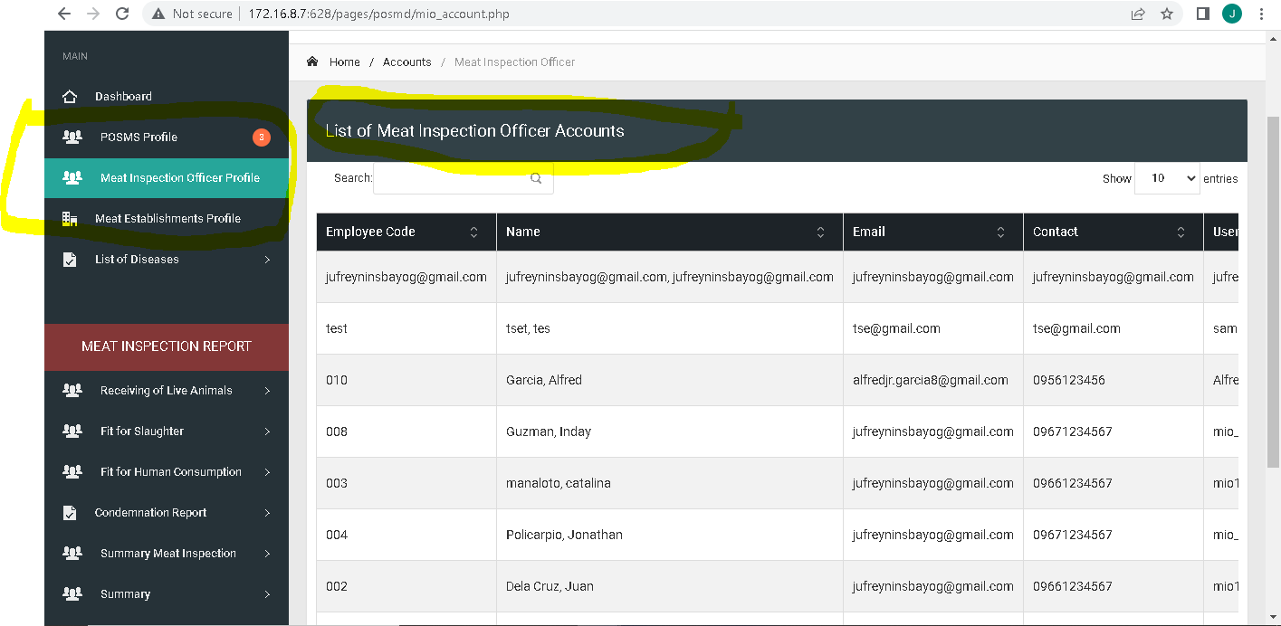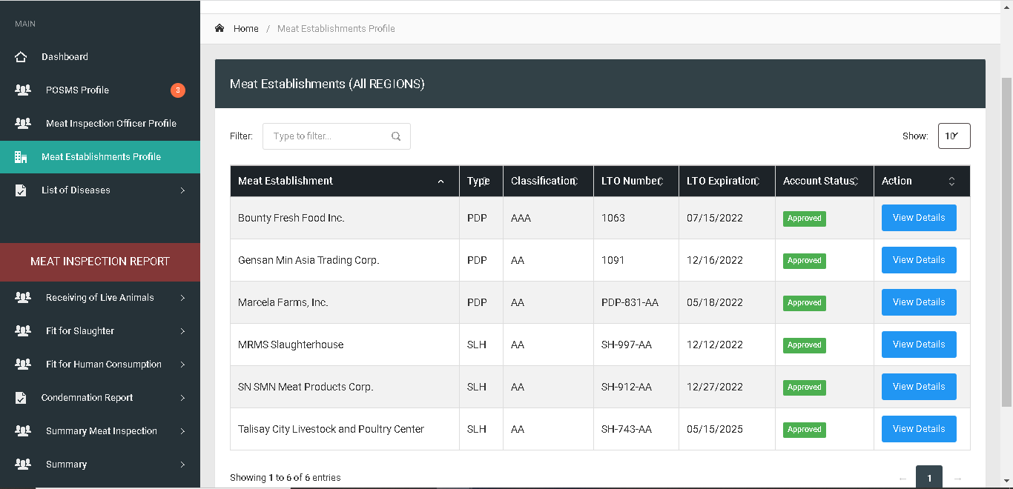

**Remove “d” on approved**

**Remove header modal leave modal body**

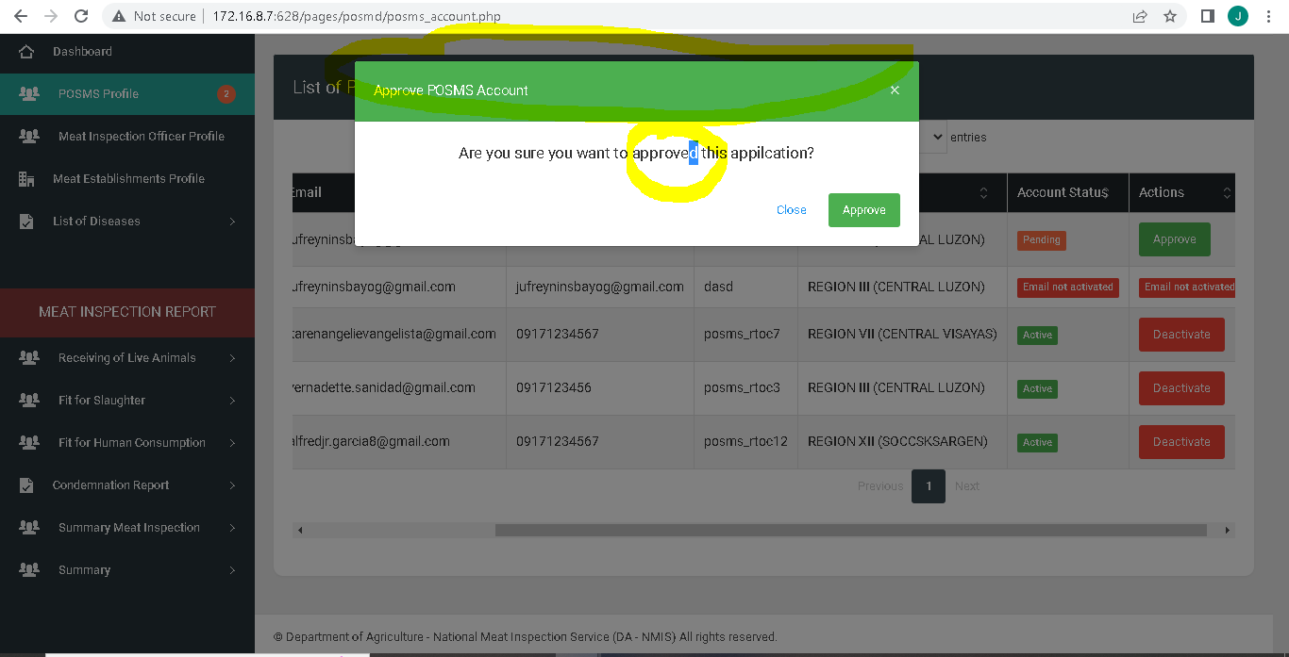

Remove Header Modal leave modal body

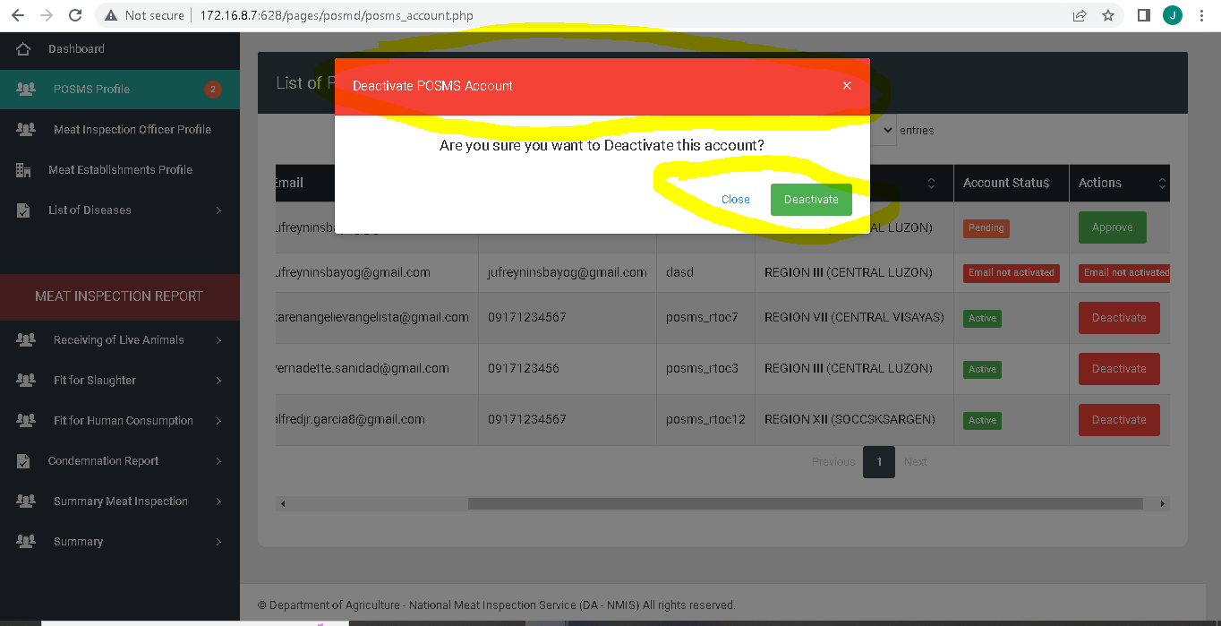

Account status “Pending, Rejected, Active, Deactivated”

Actions: “Approve, Disapprove, Deactivate, Activate,”

To be included on USER’S MANUAL define each.

Remove Breadcrumbs in all pages.



1st column : Total Number of Animals Received

2nd Column: Total Number of Animals Slaughtered

3rd Column: Total Volume of Meat Fit For Human Consumption

Fit for Human consumption specify What kind of meat additional column after head count

Species | head count |Meat type | Weight : Column order

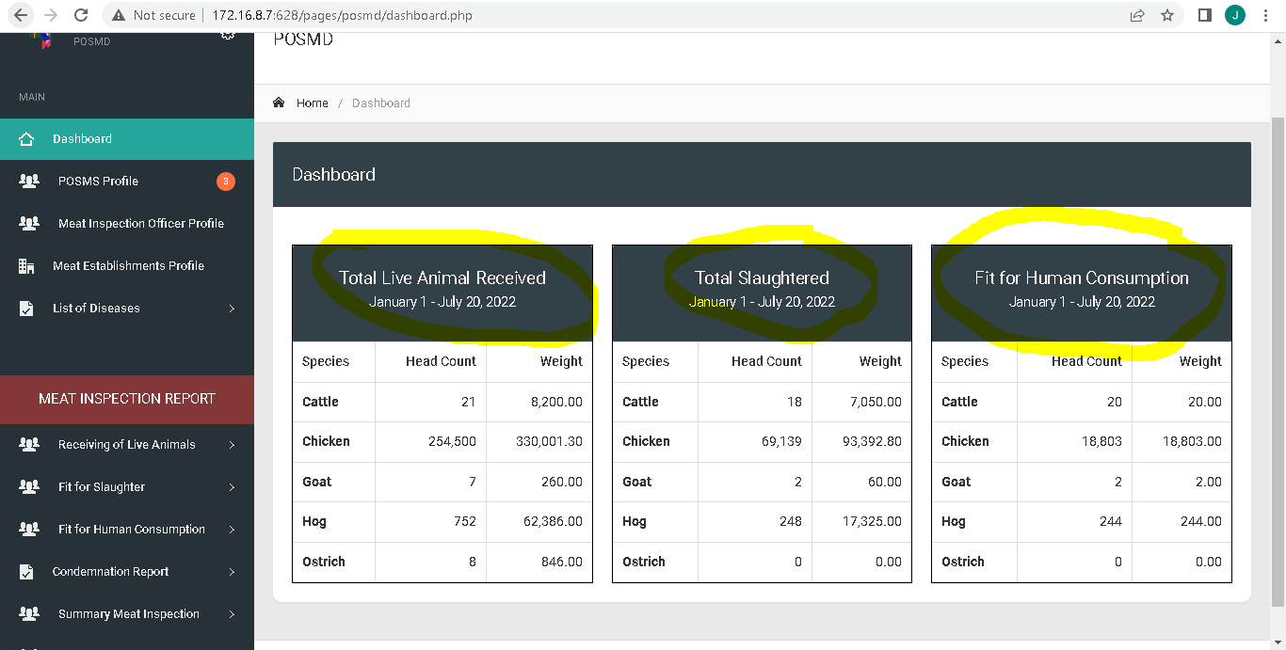

Remove “S” in meat establishments

Assign region to Region Assigned

History … Change to Previous meat establishment assignments

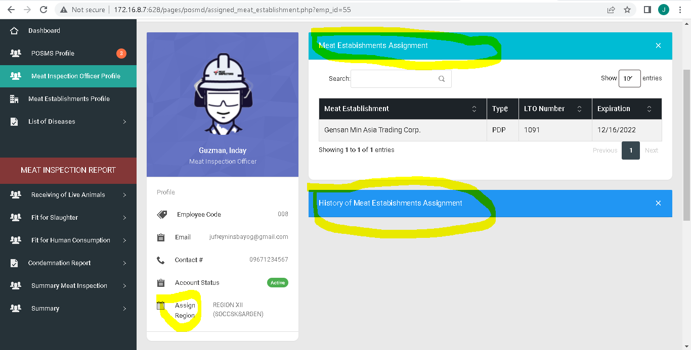

Previous ME assisngment

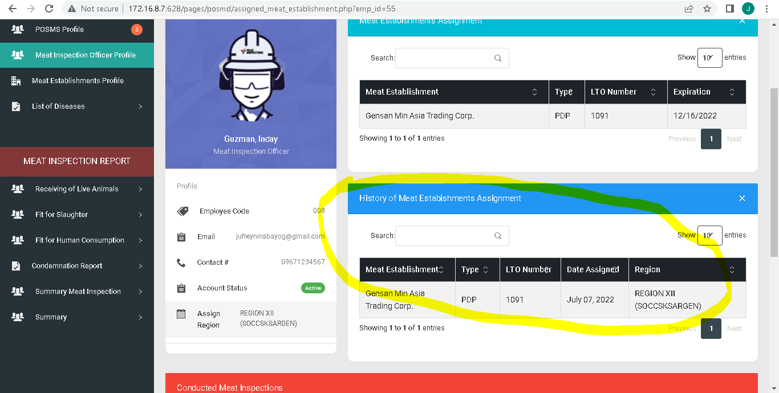

Start Date & End date of date assignment:

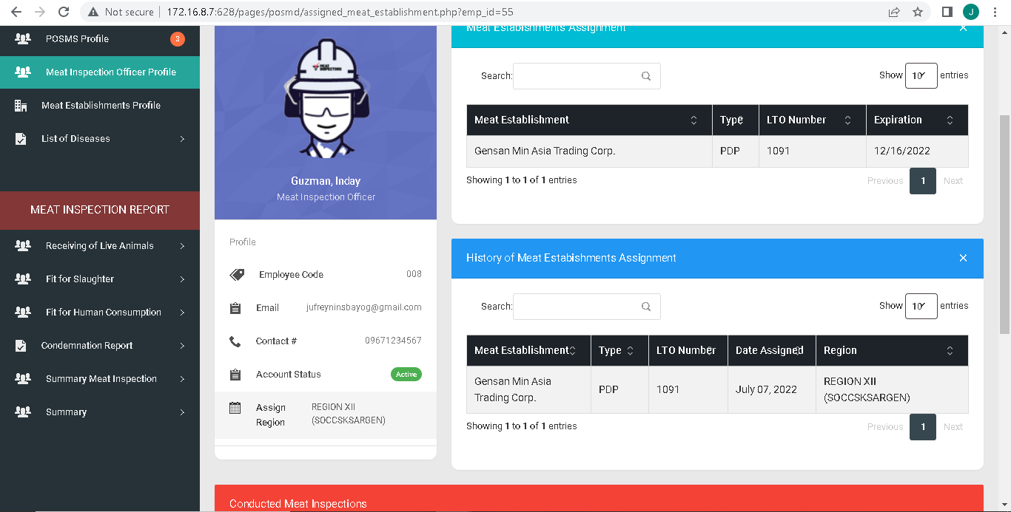

Conducted Meat Inspections to Meat Inspection Activities

Establishment name to Meat Establishment

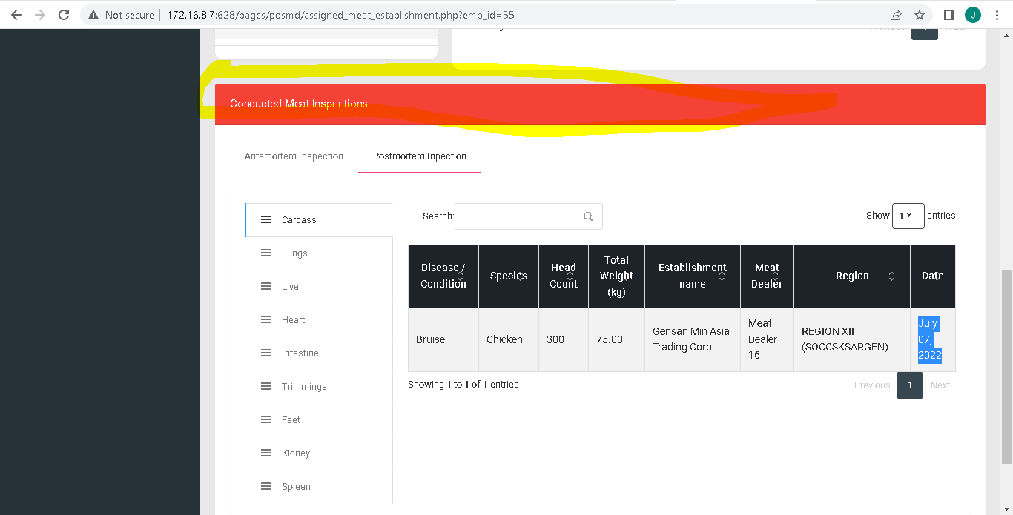

Additional column region after meat establishment

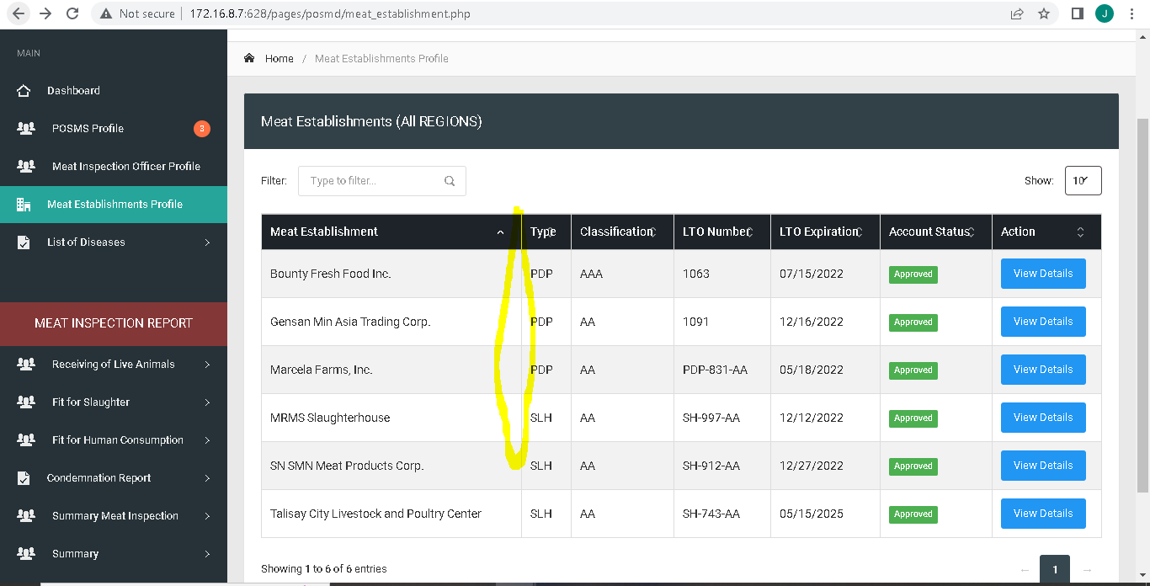

Assigned Meat Inspection Officer

Previous Meat Inspection Officer

Remove “x” in the collapsable card

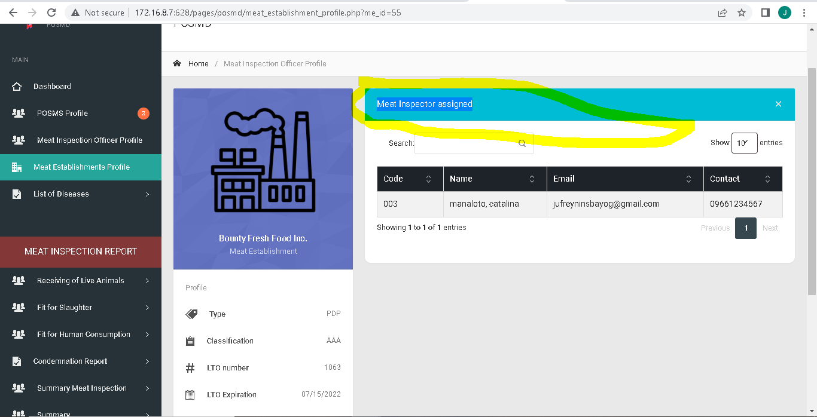

Spacing “Address”

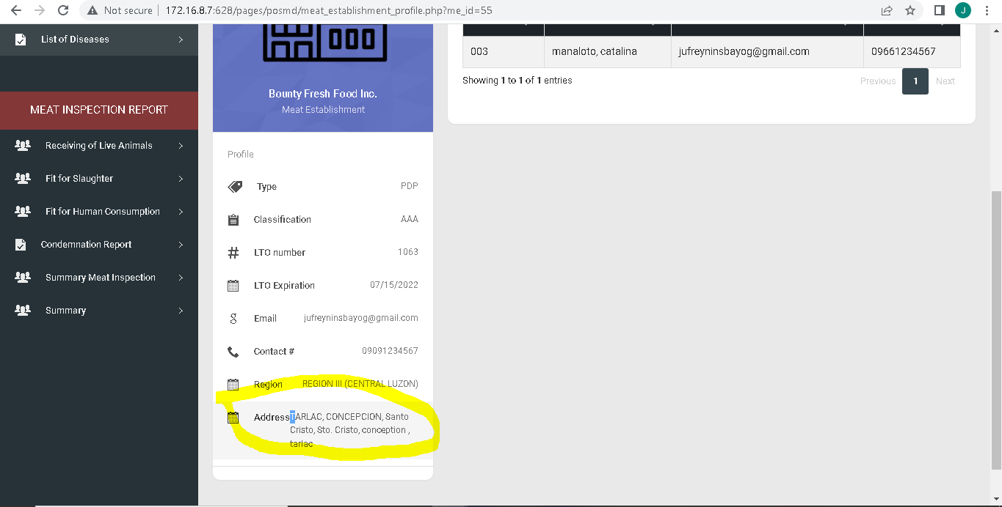

Make landscape all cards

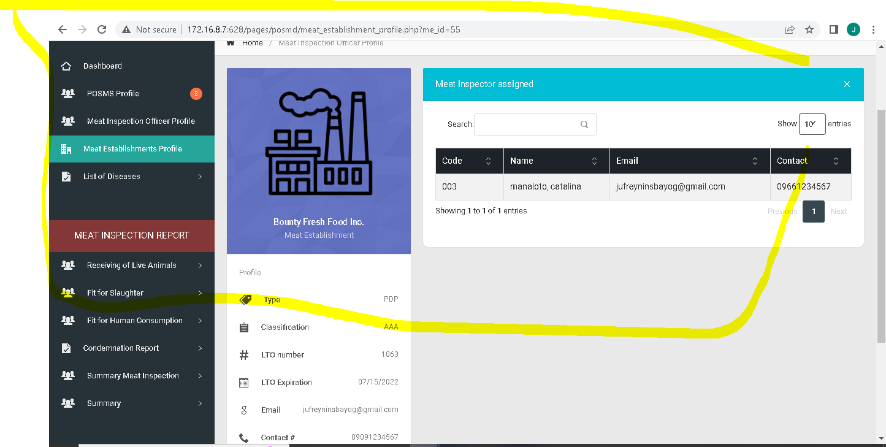

Edit table header to “Actions”

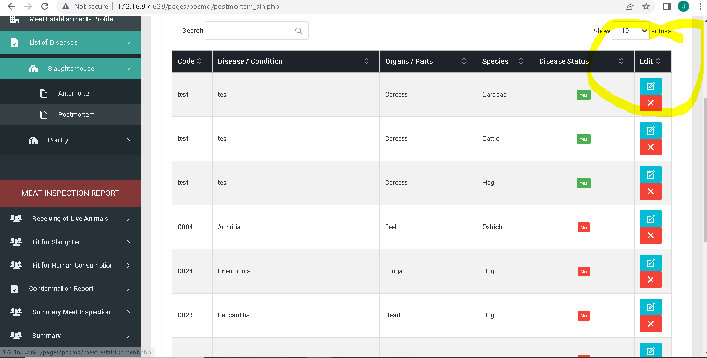

Remove “Philippines

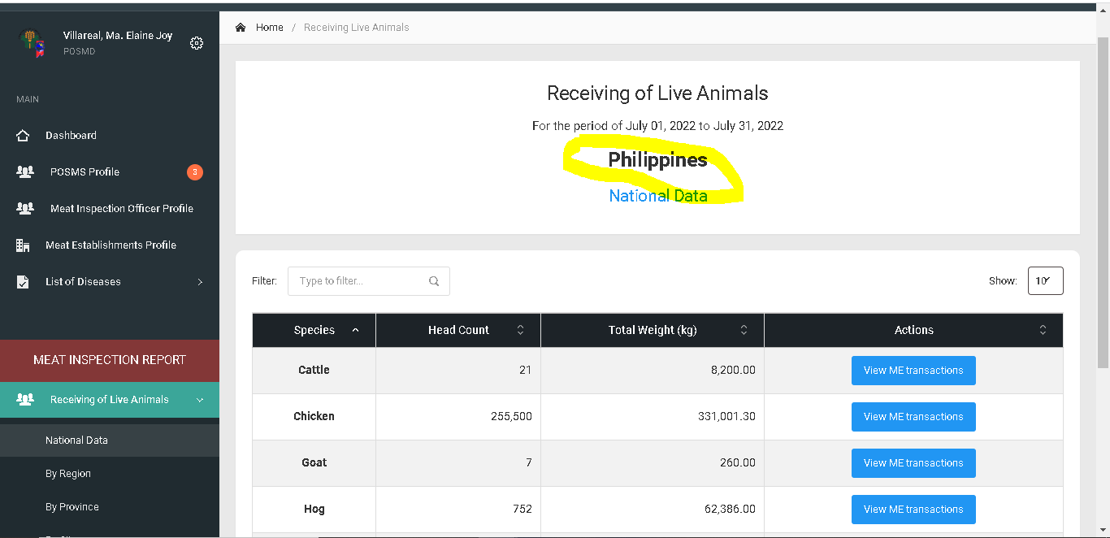

Receiving of live animals change to Receiving of Animals (all pages, side bar) Header in meat inspection report

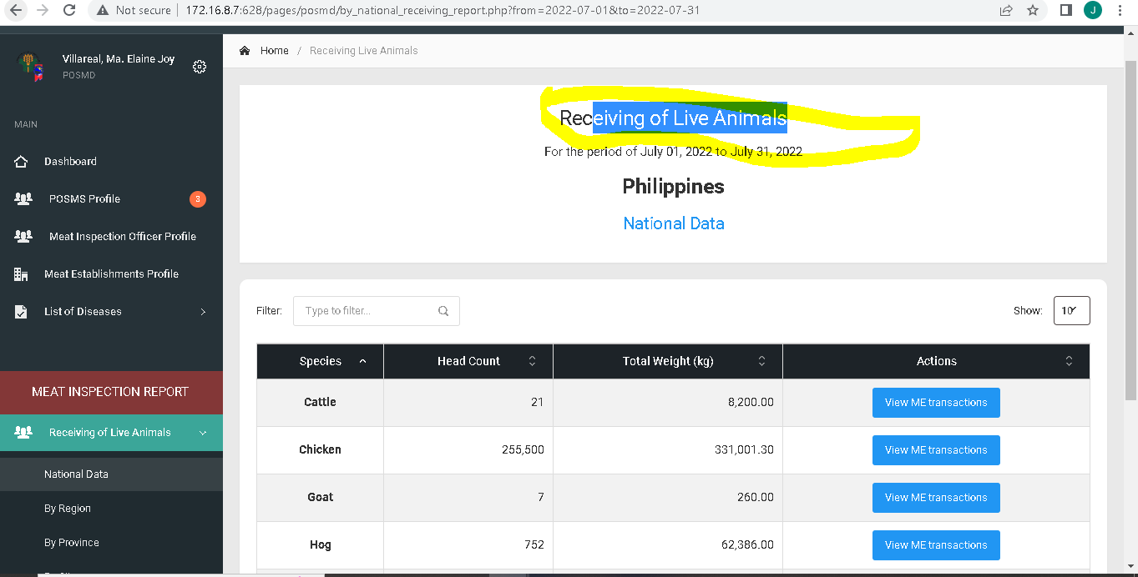

Additional meat establishment category on dropdown

Pagsamahin sa isang page ang bawat category ng national sa sidebar at base kung saan huminto sa pag pifill up ng user

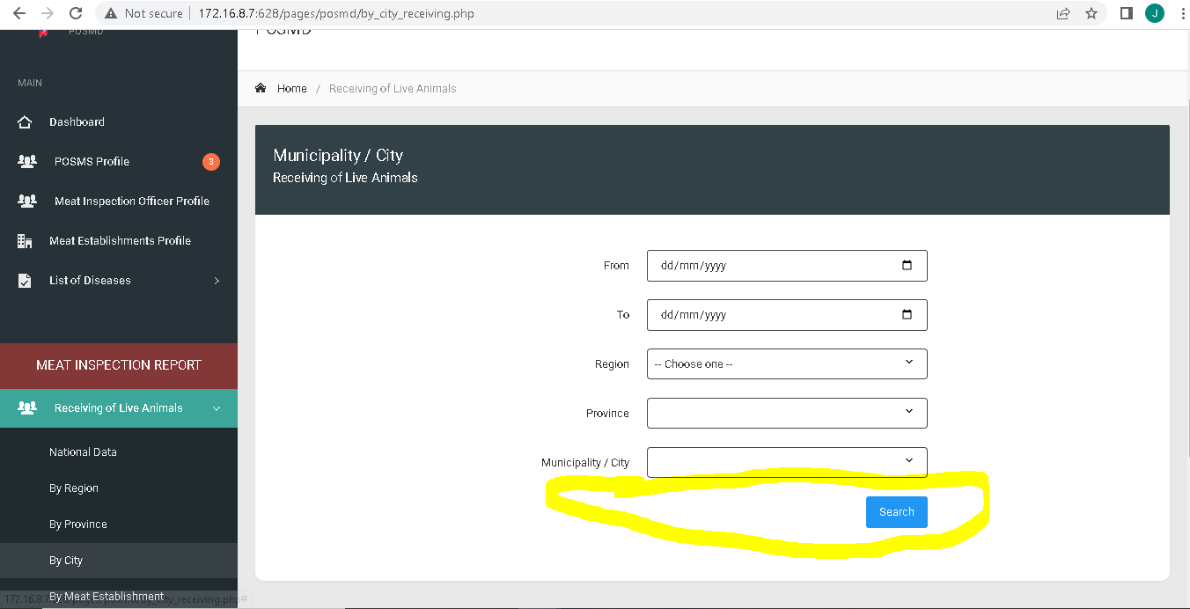

Sidebar :

Remove By: Regional Data, Provincial Data, City / Municipality Data, Meat Establishment Data

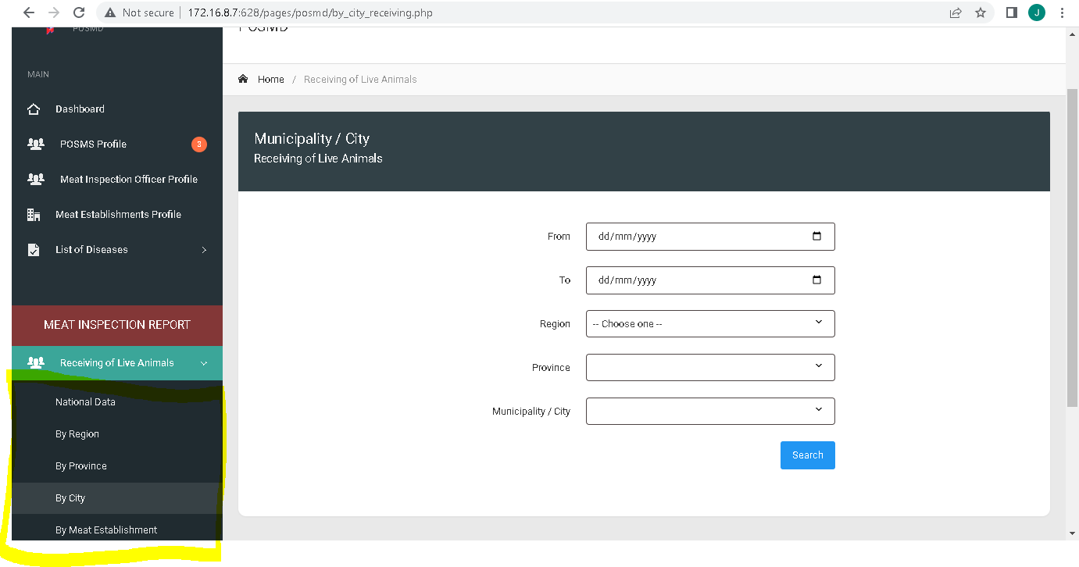

When filtering date start and end present date must be selected

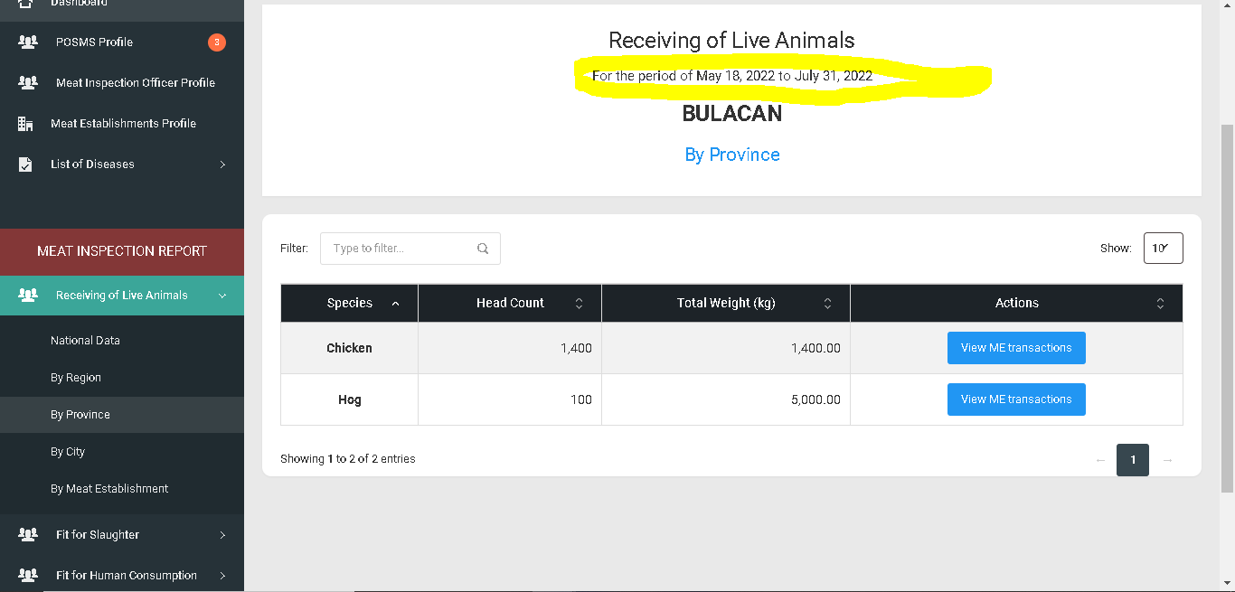

Move to Fit for human consumption and add additional card for the breakdown based on the category

Example: if region is selected on sidebar the other card will be the breakdown for province same in summary patch on july 20,2022

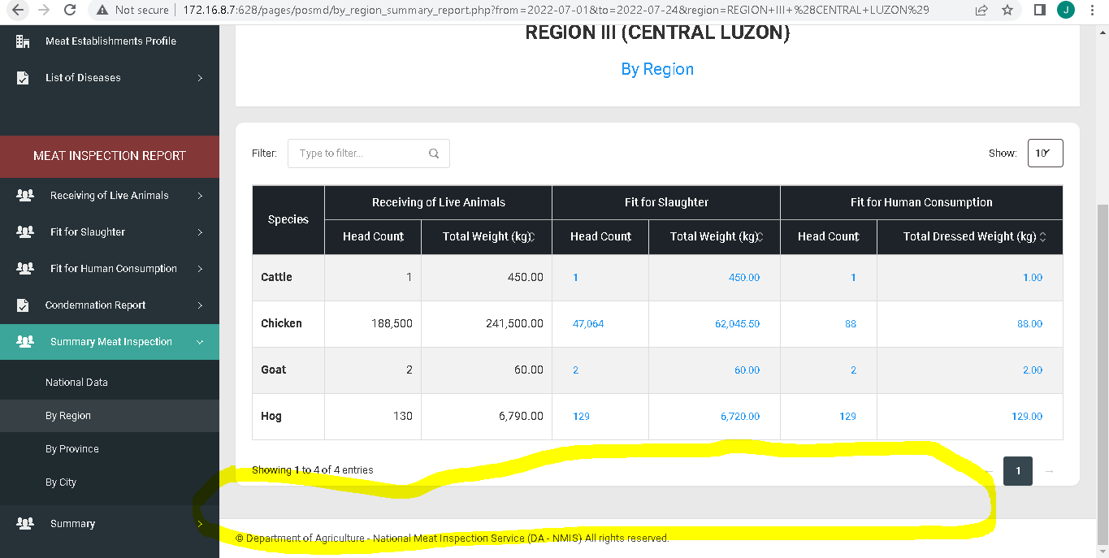

Spacing Sidebar

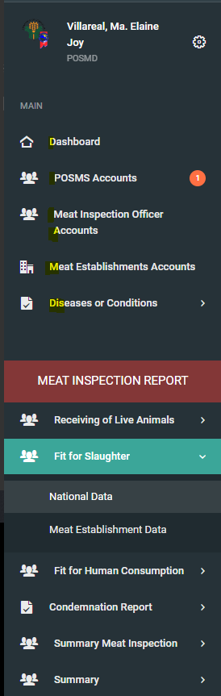

Add meat type in Fit for human consumption

